Cpp Convention – Class

# 1

Each class has its own dedicated header file $.h$ and source code file $.cpp$

# 2

Header file comment

image

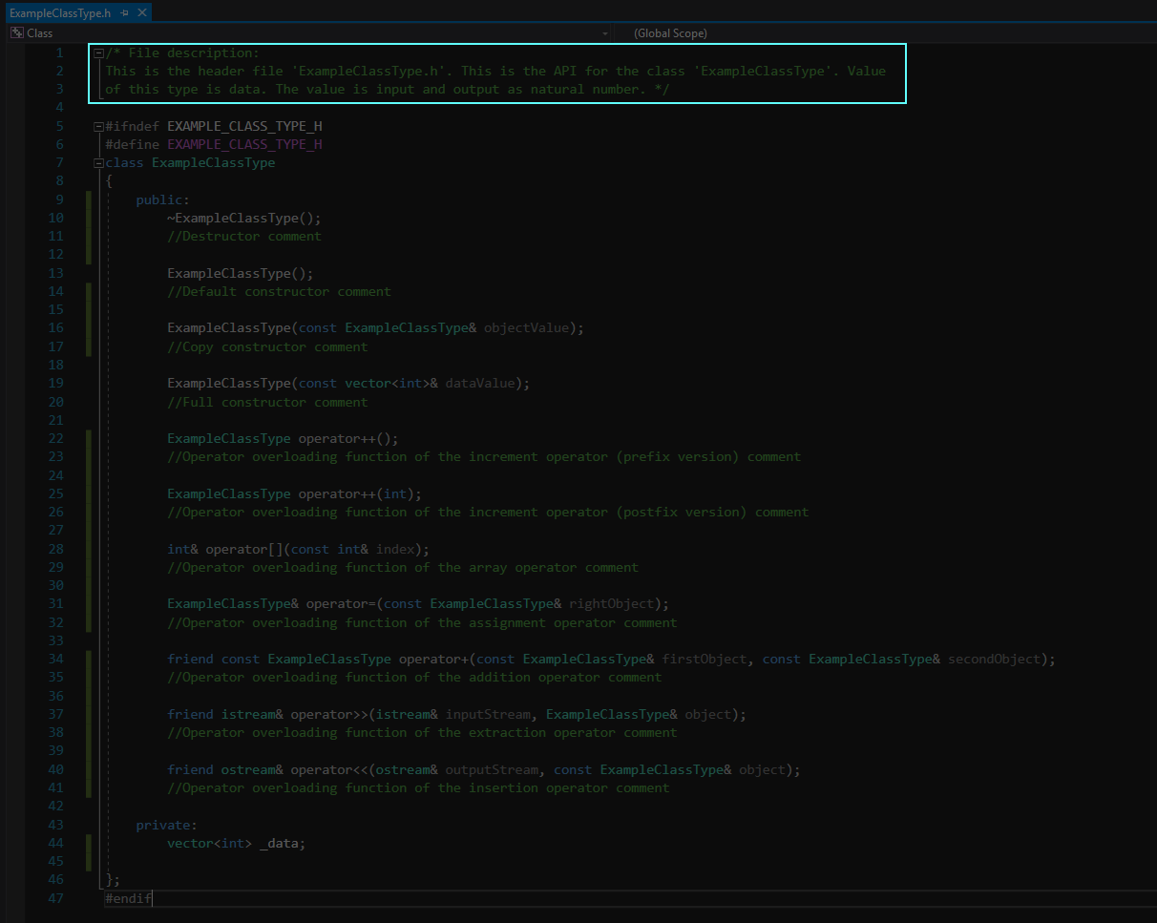

image end

# 3

Source code file comment

image

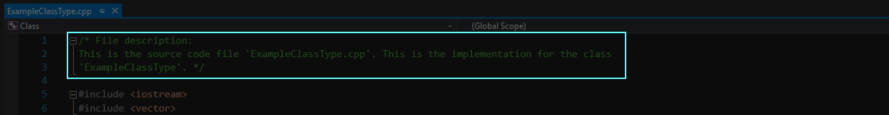

image end

# 4

A source code file $.cpp$ must obey the following order to include the header file $.h$ of a class

image

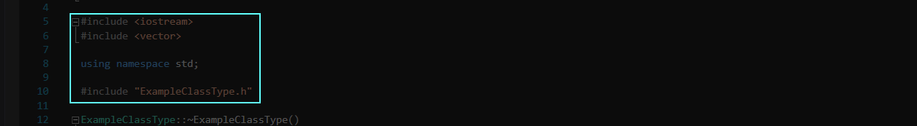

image end

A source code file including the header file of a class must contain instructions (if any)

# 5

Class definition

Class definition defense – Avoiding multiple definitions of a class

image

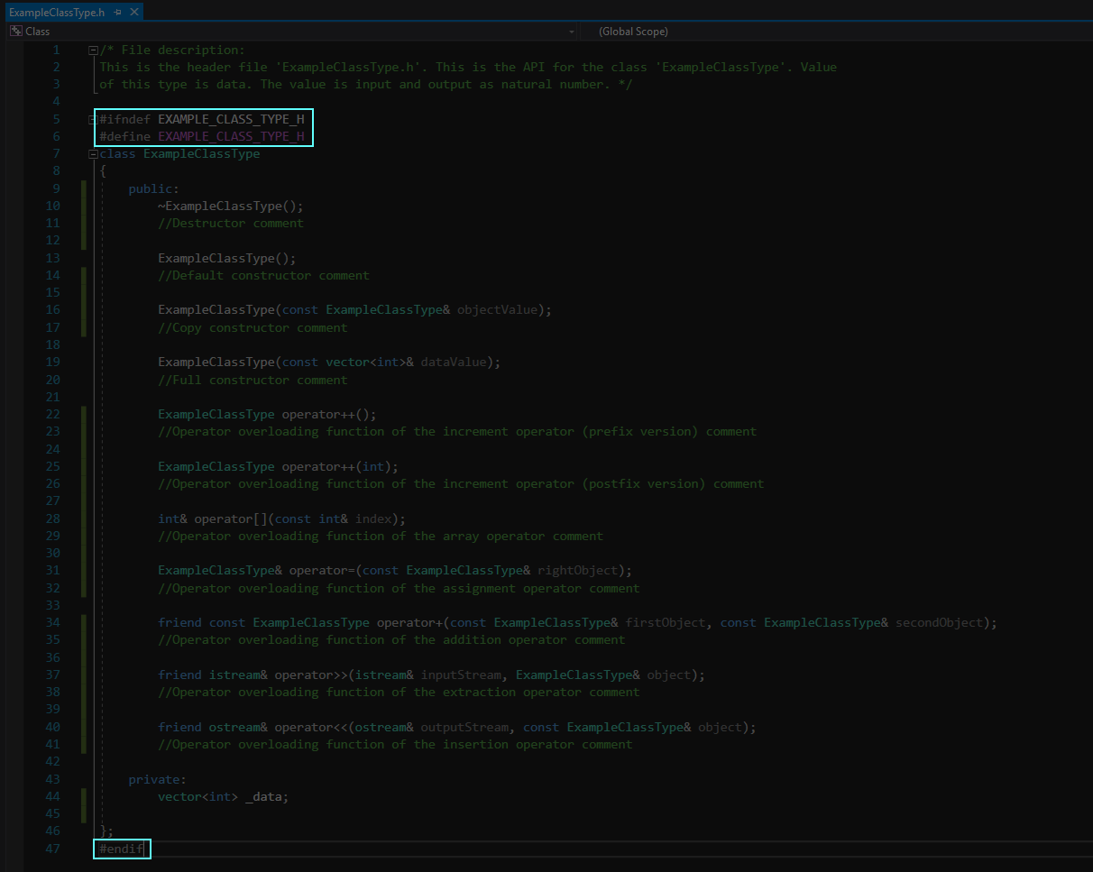

image end

Public first, Private second

Class member variables must be private

Class member variables name starts with the underscore symbol

# 6

Constructor definition

Use both initialization section and definition’s body (for checking errors)

image

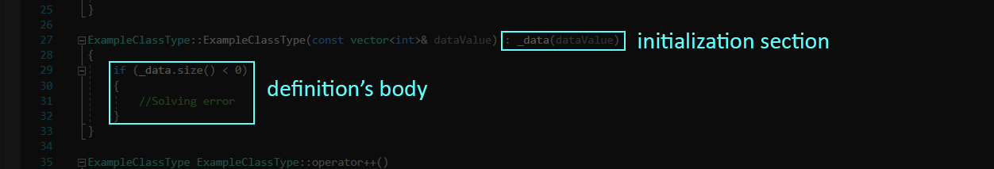

image end

Always use constructor delegation

image



image end

# 7

ACCESSOR FUNCTION DECLARATION AND DEFINITION

Use $'const'$ modifier

If return member variables, return as a constant return-by-reference value

# 8

Class static variables must be initialized in the source code file $.cpp$ of the class

# 9

Class friend functions must be declared and defined in the header file $.h$ and the source code file $.cpp$ of the class, respectively

# 10

Parameter name of constructor:

Parameter name of Set member function:

# 11

OPERATOR OVERLOADING FUNCTION TEMPLATES

## Addition operator

image

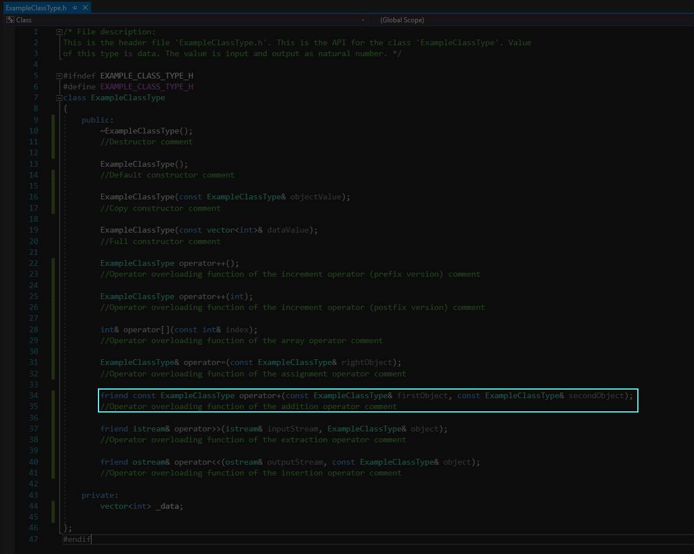

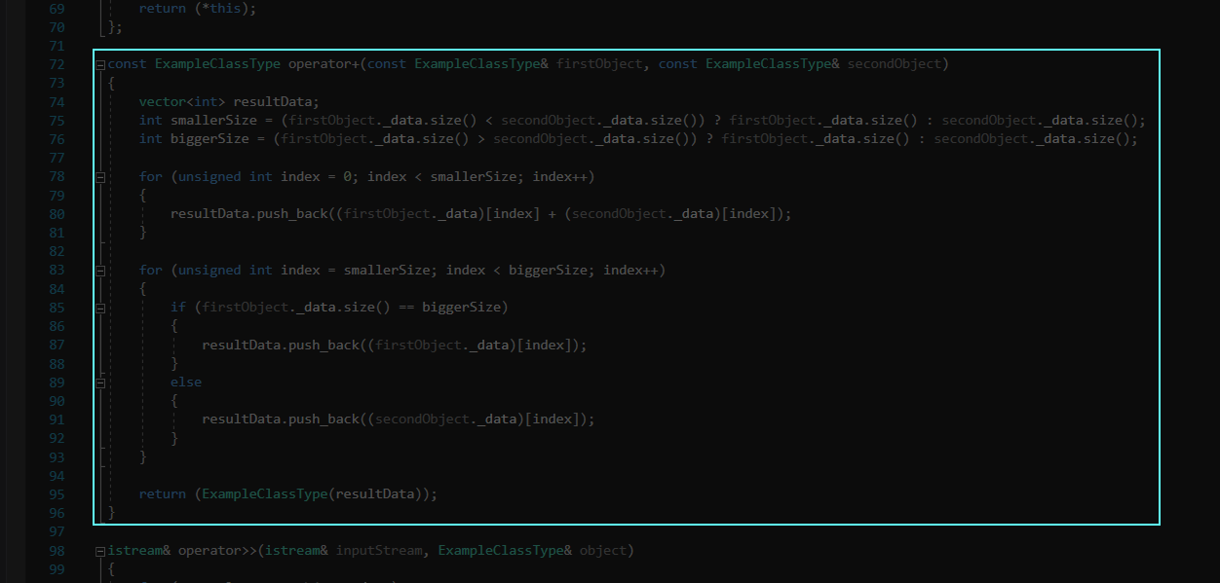

image end

## Increment operator (prefix version)

image

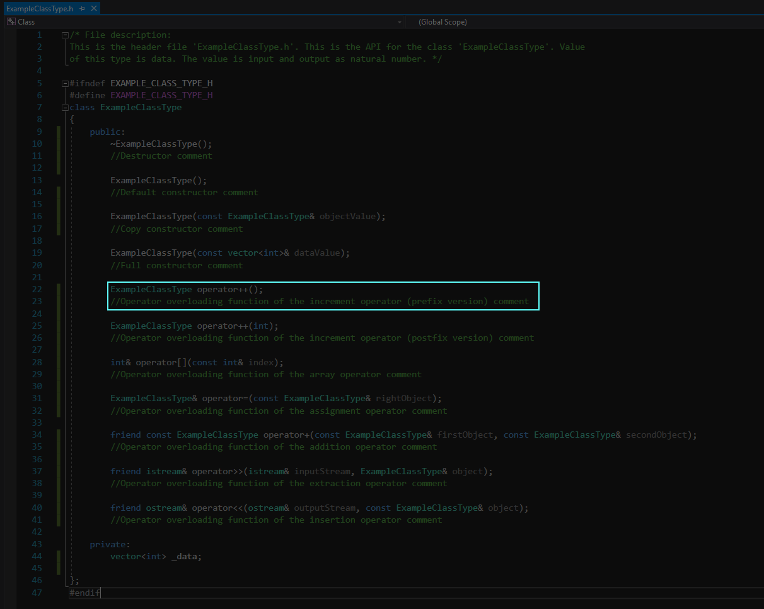

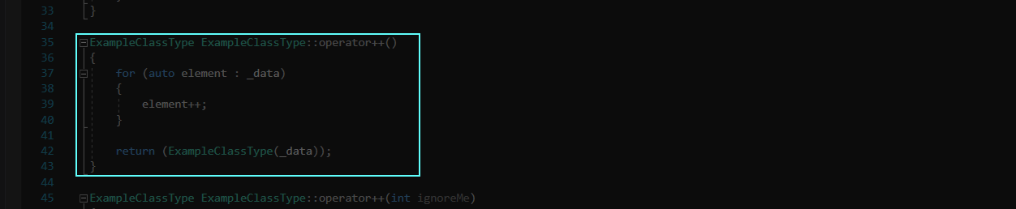

image end

## Increment operator (postfix version)

image

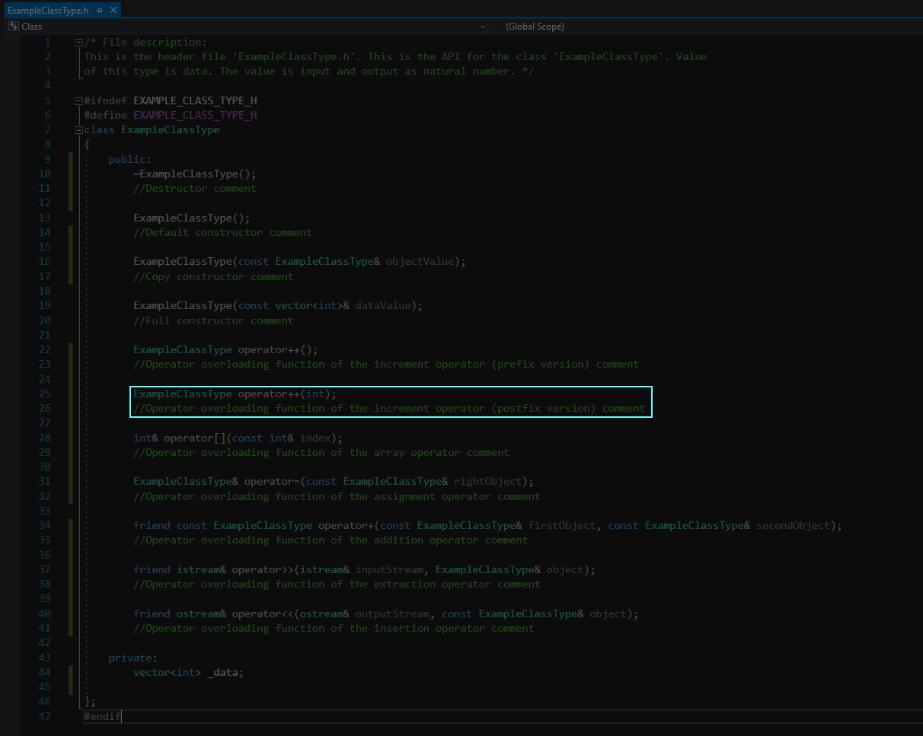

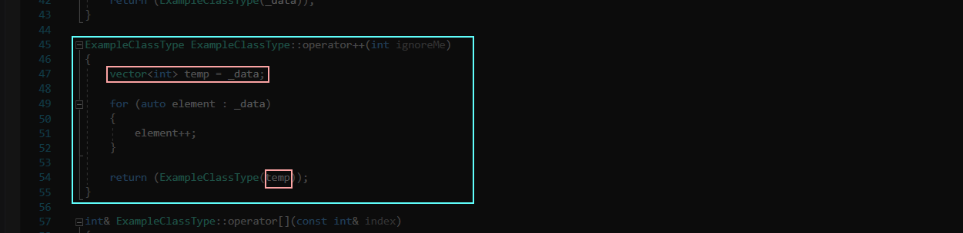

image end

## Extraction operator

image

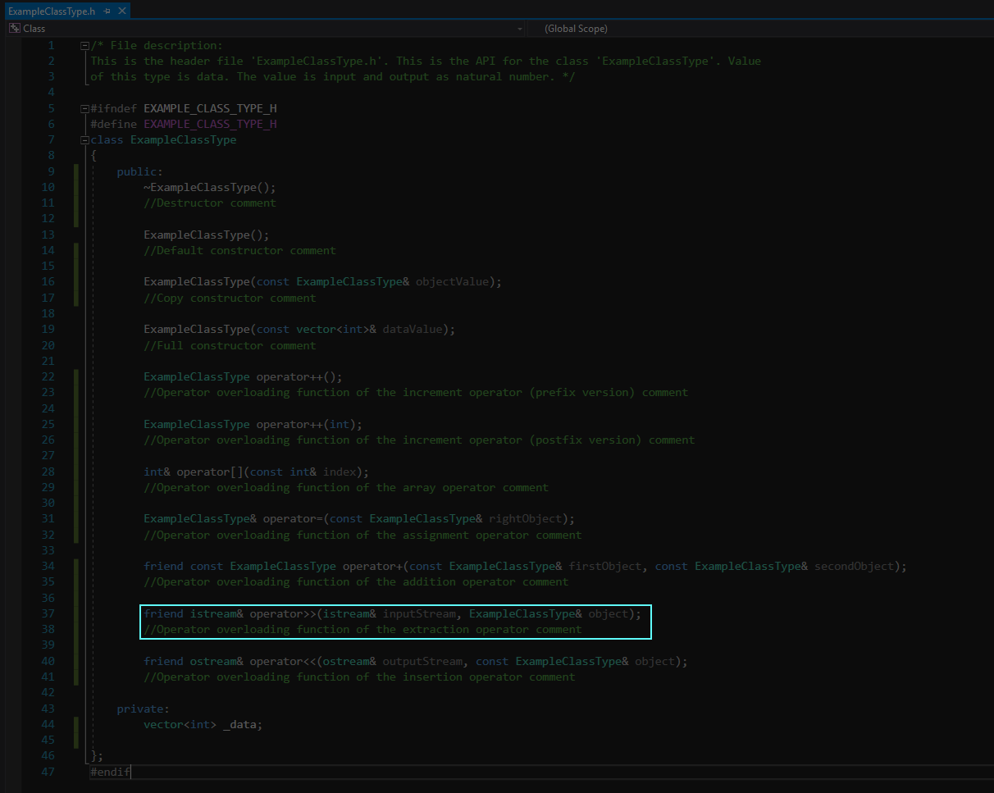

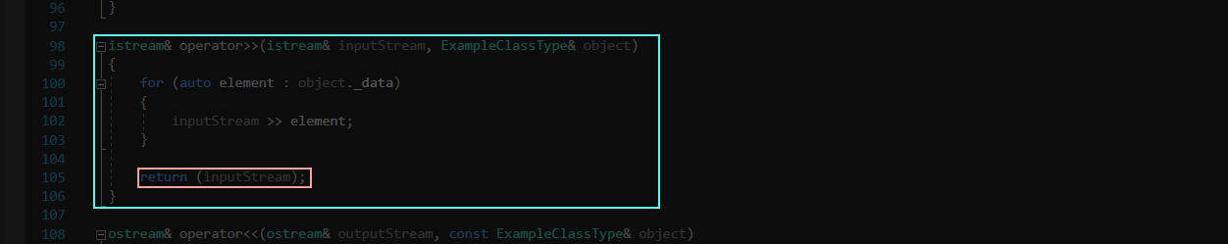

image end

## Insertion operator

image

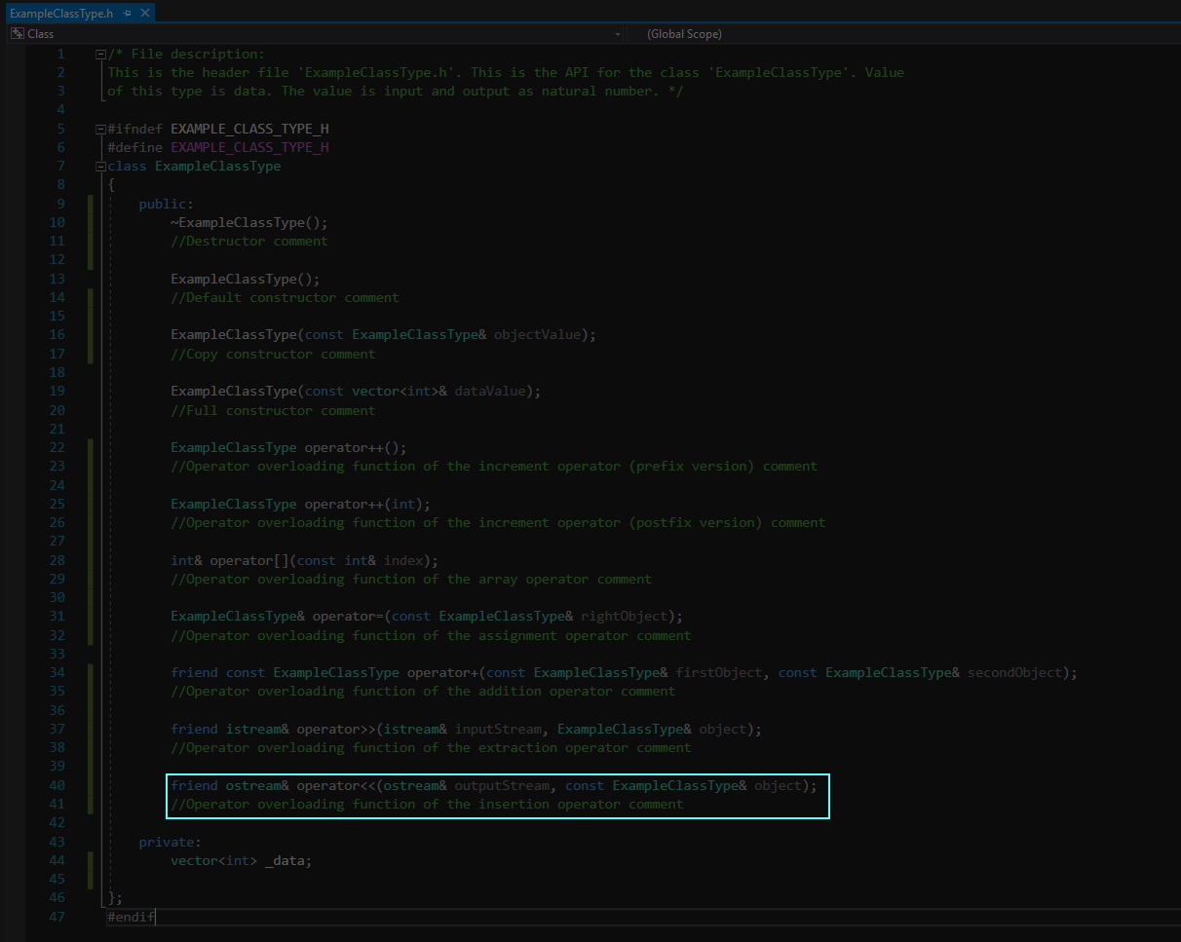

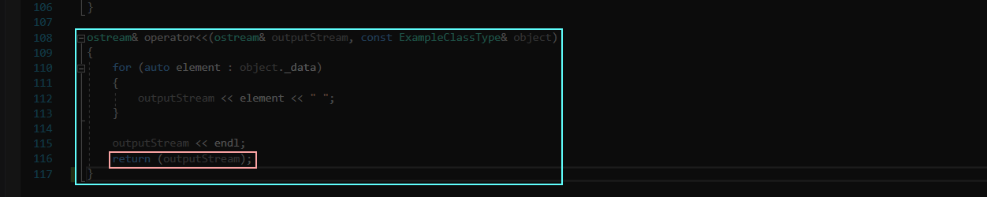

image end

## Array operator

image

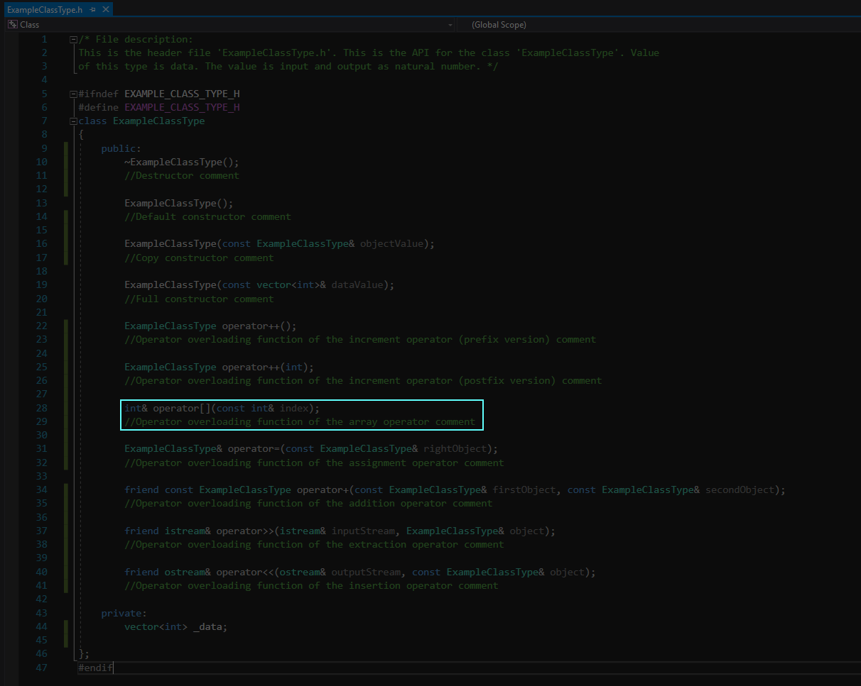

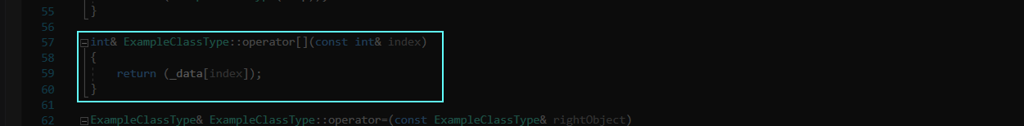

image end

## Assignment operator

image

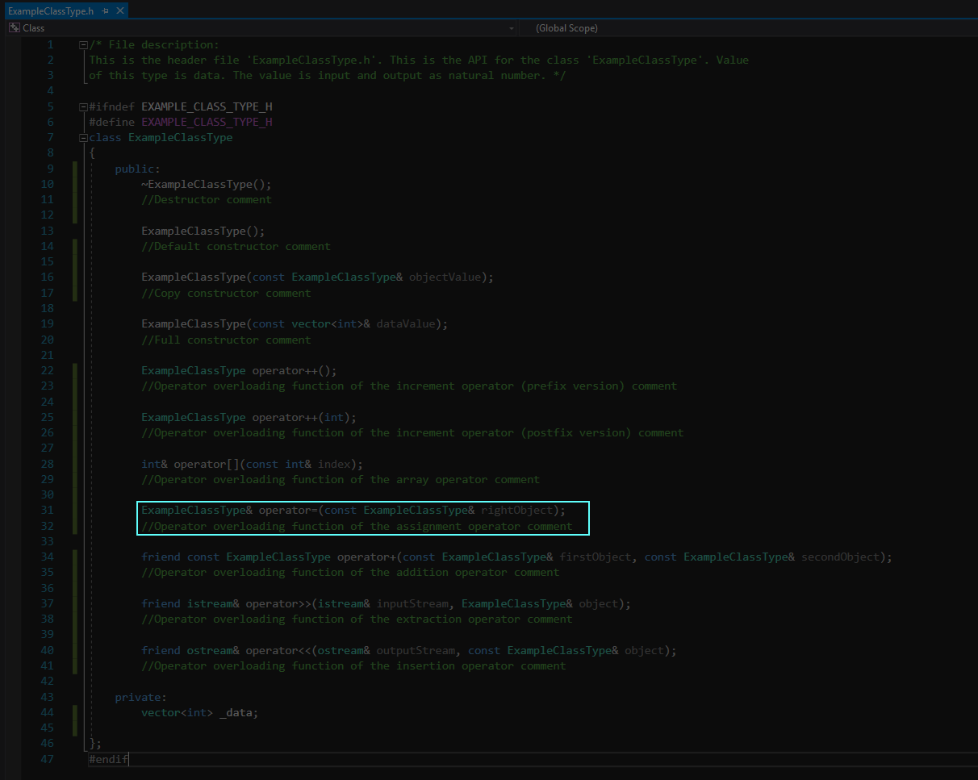

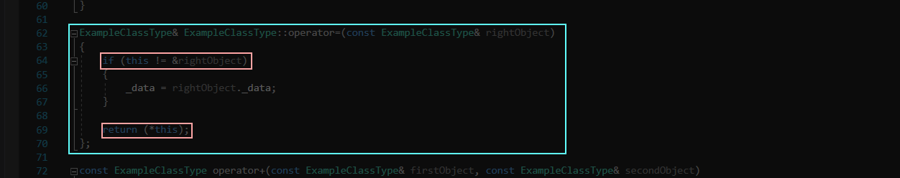

image end

# 12

CLASS DEFINITION (continued)

Always contains destructor, default constructor, copy constructor, full constructor, operator overloading function of the assignment operator

image

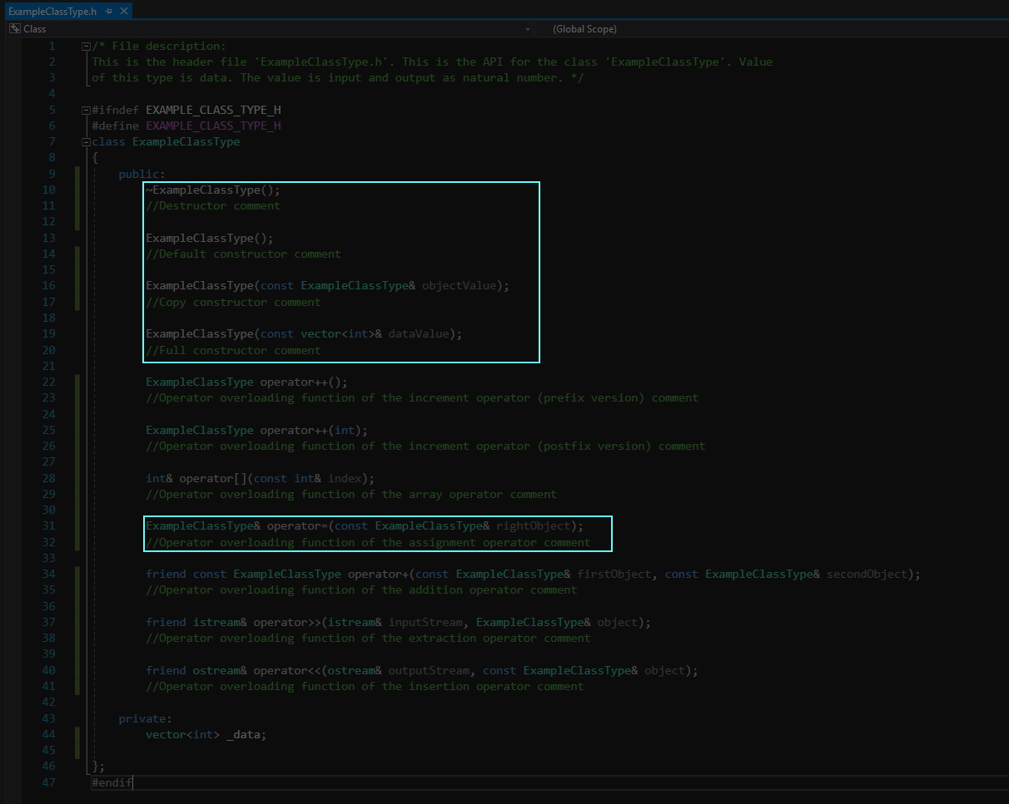

image end